**SOH CAH TOA!**

Examples:

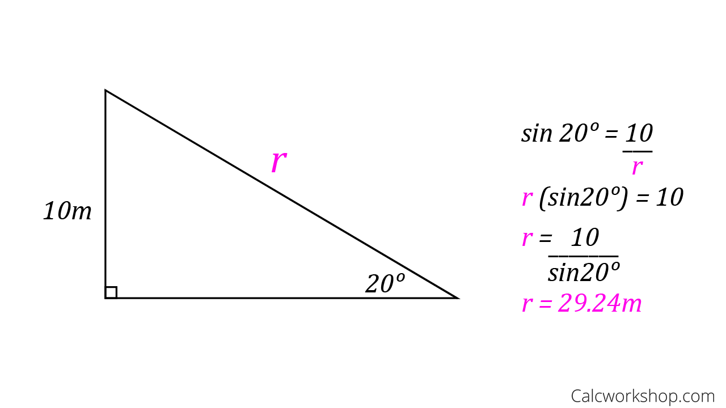

Variable is on bottom, so switch!



Solve for o.



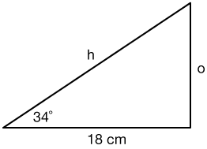



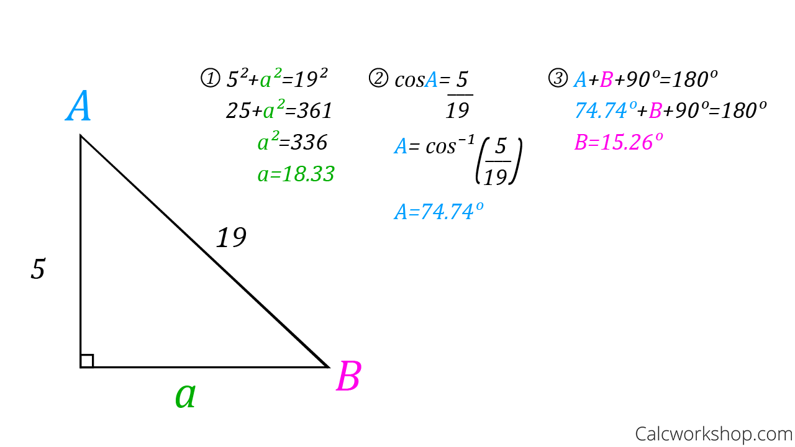

When finding an angle remember to use inverse trig (2nd function frist)



