Apprenticeship and Workplace Mathematics 11

Welcome to AWM 11
This course is designed to prepare students for many of the trades, and for those students who will enter the workplace from high school. This course has seven units.

Unit Instructions:

Each unit consists of:

- Unit Booklet containing notes, examples, assignments and answer key
- Quizzes, 1 - 3 throughout the unit
- Unit Test

Course Resources:
There is no textbook for this course, so units will be printed off and given to students to replace the textbook. These will also be posted online for easy access, in addition to videos and other helpful resources.

In order to be successful in this course:

- Follow the provided schedule set up for the course. If you do not, you will not finish on time and therefore cannot pass the course.
- We will have some classes that have more “lesson portions” that will help you cover a few assignments at a time.
- Read instructions and make sure you can follow the examples done as a class and in the booklet before beginning assignments in the booklets. Ask for help if you need it. There is no such thing as a bad question, so please ask whatever questions you need to better understand the material!
- Complete the assignments showing ALL your steps in the booklet. Note that you will be given the answer key; you must show all steps required to get to those answers. Please ensure you check your answers before submitting your work, and ask for help if needed!
- Do quizzes when indicated. Don’t go on to new work before writing a quiz.
- As you complete and hand-in assignments and quizzes, check this off your course organizer
- Before writing a Unit Test, preview the Self-Assessment statements and the vocabulary words on the back of the front page of each unit. Go over these with your teacher to ensure you are ready.

Supplies: binder, paper, pencils, erasers, calculator (no phone calculators)

Course Assessment: Your grade in this course will be based on a four-point proficiency level assessment scale based on the criterion for assessment and curricular content shown below. Formative assessments will be done throughout a unit, and summative assessment will be done at the end of a unit.

Grades for assessment will be kept on Fresh Grade so that you can always check to see how you are doing in the course. Please not that grades will be recorded using the proficiency scale below (1=emerging, 2=developing, 3=proficient, 4=extending), but you can use the conversion table below to determine your percentage range.
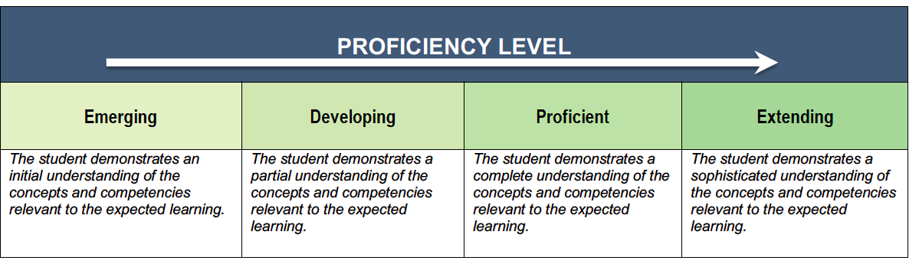

Evaluation of student learning is gathered throughout the semester through a variety of avenues.

- Observations: What is observed about student learning throughout their on-going learning process.
- Conversations with Students: What students communicate about their learning and understanding of concepts.
- Student Work: What student work demonstrates about what the student knows and can do.

Assessment breakdown:

Assignments: 20%
Quizzes: 30%
Unit Tests: 50%

Final Grade: 80% term grades, 20% Final Exam

**note: there is room for change within the assessment process, and students will have the opportunity for re-doing work if needed.

On your summative report at the end of each term, you will receive a percentage grade based on the Yukon assessment conversion table.

Curricular Content:
Students are expected to know the following:
- Financial literacy: personal investments, loans, and budgeting
- Rate of change
- How probability and statistics are used in different contexts
- Interpreting graphs in society
- 3D objects: angles, views, and scale diagrams

Curricular Competencies:
Students are expected to do the following:
- Reasoning and Modelling
- Understanding and Solving
- Communicating and Representing
- Connecting and Reflecting

The above curricular content and compentencies can be found in more detail at: https://curriculum.gov.bc.ca/curriculum/mathematics/11/courses

Workplace Math 11 Approximate Timeline

If you complete a particular unit early, move onto the next unit early. You may find some units more difficult than others and require more time on future units.

Unit # of Classes Dates

1. Working with Graphs 11 Jan 19 – Feb 2

2. Managing Your Money 12 Feb 2 - 18

3. Investing and Borrowing Money 12 Feb 19 – Mar 9

4. Solving Right Triangles 11 Mar 10 – April 12

5. Slope and Rates of Change 12 April 13 - 28

6. Scale Representations 12 April 29 – May 17

7. Probability 12 May 18 – June 3

Review for Final Exam 2 June 4, June 7

Final Exam Week June 8 - 11

